“There’s something fishy about oyster reef saltmarsh and seagrass habitats”- Part 3: Saltmarsh Structure and Habitat Biodiversity
Authors: | Alexia Pool, Miriam Sutton, Rick Harabin, Danielle Parker and Antonio Rodriguez
Author Affiliation and Location: | The University of North Carolina at Chapel Hill, Institute of Marine Sciences, 3431 Arendell St., Morehead City, NC 28557
Author Website | rodriguez.web.unc.edu
Author Contact Information | rodriguez@unc.edu
Introduction/Abstract | This lesson is designed to follow “Assessing fish-habitat value” lesson plan where the students were introduced to the saltmarsh habitat. The objective here is to have students gain insight into the provision of ecosystem services and the possible impact of human activities on saltmarsh habitat. Students will begin by examining marsh-grass density and learn about interactions between saltmarsh and the water column as it pertains to sedimentation. Next, the students will manipulate a dataset to explore habitat quality and biodiversity of saltmarsh. The lesson is in two parts, which can also be used as stand-alone exercises.
Learning Objectives | Part A:  1) Describe the characteristics of a saltmarsh.  2) Describe how saltmarsh grasses change with elevation.  3) Describe the importance of saltmarsh in preventing erosion, burying carbon and sediment, and providing habitat.  4) Extract data from quadrat images.  5) Construct graphs based on those extracted data and draw conclusions from those graphs.  Part B:  1) Explore 4 marine species commonly found in an estuarine environment.  2) Compare 17 species of marine organisms to determine their preferred habitat.  3) Analyze data provided by University of North Carolina at Chapel Hill – Institute of Marine Sciences to explore the biodiversity of marine habitats.  4) Differentiate between biotic and abiotic factors found between different estuarine substrates.  5) Identify factors that support the conservation of salt marshes.
Appropriate Grade Levels | 6-12
Group Size/# of students activities are designed for | Groups of 2-4
Setting | Indoor
Approximate Time of Lesson | 180 minutes (Parts A and B)
Resources Needed for Students | Data spread sheets, computers with graphing program (e.g. Excel), Saltmarsh video, Sandflat video, balloons or tennis balls for simulations, quadrat photos, saltmarsh density worksheet, colored pencils (optional).
Resources Needed for Educators | Smart board or projector, video-playing software and graphing software.
Apps/Websites Needed | NA
Lesson Activity (step by step description of activity) | Part A  1. Show saltmarsh video and pause at 2 minutes and 25 seconds.  2. Use students to simulate a saltmarsh at different elevation levels.  a. Arrange students in a similar format as shown below (birds eye view; X=student):  X X X XXXX  Low Tide X X X XXXX High Tide  X X X XXXX  (Seated (Seated (Standing)  on floor) on chairs)  b. Explain that students represent saltmarsh grass at different elevations. Students seated on the floor represent the lowest elevation. Students seated in chairs represent the mid elevation and students standing represent the highest elevation.  c. Choose additional students to represent water flowing through the elevations. Have these students walk from low tide to high tide. Have students make observations about the fluidity of the “water”.  d. Remind students that water carries sediment. Give each student that represents water a tennis ball or balloon to represent sediment. Instruct students to perform the simulation again, but this time, trying to avoid the students representing the shoots. If they touch a “shoot” then they must drop the “sediment”. Students should observe that more sediment “settles” at the higher, more dense, saltmarsh area.  3. Continue the video and when it is over, set up the quadrat activity.  4. Divide students into groups of 3 or 4.  5. Pass out Saltmarsh Structure Worksheet. Have students hypothesize if there are variations in density between high, middle, and low saltmarsh elevations and why. Have students write their hypothesis on their worksheet.  6. Assign each group to low, middle, or high elevation. (If the class is large, multiple groups can be used). Pass out assigned quadrat photos or use computers.  7. Instruct students to count shoot density in each quadrat photo. Demonstrate that shoot density is measured by identifying the individual stem, not individual blades. Dead shoots are NOT counted. Teachers should allow students to set up a standard method across groups for counting the shoots. Students should be instructed to use their best approximation of shoots per quadrat. Whichever method they decide to use, consistency and an explanation of their method is important.  8. Have students record their data by drawing a picture of the quadrat displaying number of shoots. Fill in the number of shoots and quadrat elevation in the appropriate areas.  9. Come together as a class to create a graph displaying each group’s data. Data can be graphed as each group’s average or as number of shoots per elevation.  10. In-class discussion, have the students draw conclusions from the graph. Reconvene in groups to answer the discussion questions on the worksheet.  Part B  Step 1: Show the videos “Saltmarsh” and “Sandflat” and pass out the provided worksheet (“data_worksheet.docx”).  Step 2: Construct a Venn Diagram to compare the abiotic and biotic factors that characterize sandflat and saltmarsh habitats.  Step 3: Have the students discuss the following questions (10-15min) a) Which habitat (sandflat or saltmarsh) will have the highest number of species and abundance of fish living in it? b) Why would the fish live in the habitat you have chosen? c) How would biodiversity vary with different substrates in an estuarine environment?  Step 4: The students should now look at the data table provided from UNC IMS (“saltmarsh_sandflat_trawl_data.xlsx”). Data are based on trawling samples from saltmarsh and sandflat habitats.  a) Graph the different species concentrations found in both the marsh and sandflat habitats in a graphing program (it is important to have them convert the graph created to log scale). The image, below, is provided as an example. (20-30min).  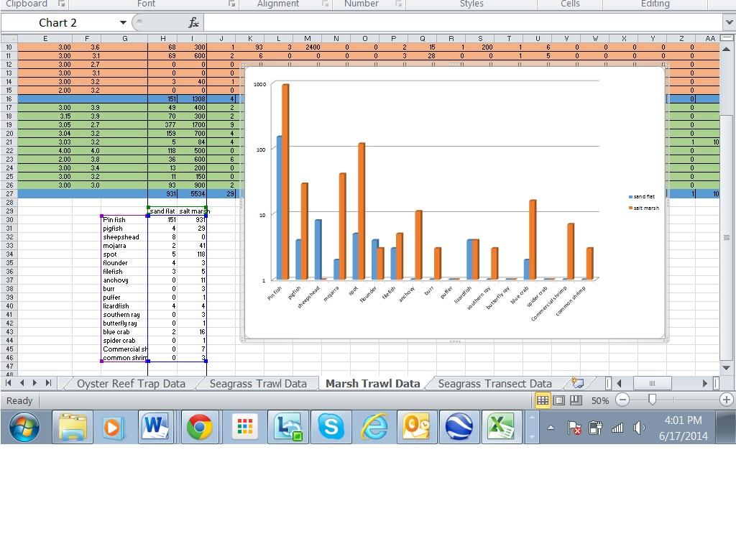  5. The students should analyze the graphs and answer the questions found on the provided worksheet (“data_worksheet.docx”; 15-20min).  i) Which habitat had the most fish living in it?  ii) Are there any differences in fish characteristics (e.g. size) among habitat types?  iii) Were there any fish sampled in a habitat that you did not expect to be there?  iv) Which of the habitats may be more important to fish and why?  6. Students will locate images of those fish species sampled in each habitat on the web (listed in the data table; 5-10min).
Final Product | Students will hand in the completed worksheets and graphs.  Students will create a PPT to communicate their data and findings to the class.
Assessment/Evaluation | Evaluate the quality of students’ PPT presentation and worksheets. Assessment would be based on:  -Correctness of the graphs produced.  -Quality of final products showing clear data-driven support for their findings.
NC Essential Standards: Earth/Environmental Science | Middle School  6.L.2 Understand the flow of energy through ecosystems and the responses of populations to the biotic and abiotic factors in their environment.  8.E.1 Understand the hydrosphere and the impact of humans on local systems and the effects of the hydrosphere on humans  Biology  Bio.2.1 Analyze the interdependence of living organisms within their environments  • Generalizing that although some populations have the capacity for exponential growth, there are limited resources that create specific carrying capacities and population sizes are in a dynamic equilibrium with these factors. (e.g. food availability, climate, water, territory).  Bio.2.2 Understand the impact of human activities on the environment (one generation affects the next).  • Explain factors that impact North Carolina ecosystems. (Examples: acid rain effects in mountains, beach erosion, urban development in the Piedmont leading to habitat destruction and water runoff, waste lagoons on hog farms, Kudzu as an invasive plant, etc.). Exemplify conservation methods and stewardship.  Earth and Environmental Science  EEn.2.2 Understand how human influences impact the lithosphere.  • Explain the effects of human activity on shorelines, especially in development and artificial stabilization efforts.  EEn.2.7 Explain how the lithosphere, hydrosphere, and atmosphere individually and collectively affect the biosphere  • Compare impacts of biotic and abiotic factors on biodiversity  • Infer the relationship between environmental conditions and plants and animals that makeup and live within various biomes that comprise the biosphere.  • Explain effects of human population growth, habitat alteration, introduction of invasive species, pollution and overharvesting on various plant and animal species in NC.  • Summarize ways to mitigate human impact on the biosphere.  Major Themes in AP Environmental Science  • Science is a process.  • Science is a method of learning more about the world.  • Science constantly changes the way we understand the world  • The Earth itself is one interconnected system.  • Natural systems change over time and space.  • Biogeochemical systems vary in ability to recover from disturbances  • Humans alter natural systems.  • Humans have had an impact on the environment for millions of years.  • Technology and population growth have enabled humans to increase both the rate and scale of their impact on the environment  • Human survival depends on developing practices that will achieve sustainable systems.  • A suitable combination of conservation and development is required.  • Management of common resources is essential  Big Ideas for AP Biology  • Organism activities are affected by interactions with biotic and abiotic factors  • The stability of populations, communities and ecosystems is affected by interactions with biotic and abiotic factors.  • The structure of a community is measured and described in terms of species composition and species diversity  • Human activities impact ecosystems on local, regional and global scales  • Interactions between populations affect the distributions and abundance of populations
Next Generation Science Standards | MS-LS2-2. Construct an explanation that predicts patterns of interactions among organisms across multiple ecosystems.

Appendices:
Part A:
Quadrat photographs
Saltmarsh Structure Worksheet.doc
Part B:
PPT Template.pptx
Saltmarsh_sandflat_trawl_data.xlsx
Sample Graph.jpg
Data_worksheet.docx

